Smoothies
Berry Tropical Oat Milk Smoothies
5 min · 124 cals · 4 servs
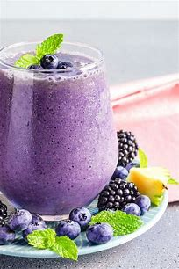
Ingredients
- 1 ½ cups Almond Milk (or unsweetened oat milk)
- 2 Ripe Bananas (sliced and frozen)
- 1 cup Pineapple (frozen chopped)
- ½ cup Baby Spinach
- ⅓ cup Blackberries
- ¼ cup Old-Fashioned Rolled Oats
Nutritional facts
Calories124% Daily Value
Instructions
Add the milk beverage, bananas, pineapple, spinach, blueberries, blackberries, and oats to your blender and puree until smooth.
Divide the smoothie between 4 glasses to serve.
Nutrition Information
Calories: 124 Fat: 2g Carbohydrates: 27g Sugar: 14g Sodium: 76mg Fiber: 4g Protein: 3g
Strawberry Smoothie
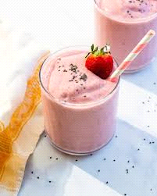

Ingredients
- 2 cups frozen strawberries
- 1 banana (room temperature)
- ¼ cup Greek yogurt*
- 1 cup milk (or almond milk or oat milk)
- 1 ½ tablespoons maple syrup, honey, or agave syrup
- ½ cup ice
- Optional add-ins: 1 tablespoon almond butter, ¼ teaspoon vanilla, fresh mint leaves or basil leaves

Instructions
Place all ingredients in a blender, breaking the banana into pieces. Blend until creamy and frothy, stopping and scraping down the sides as necessary. If desired, garnish with a frozen strawberry and mint sprig. Serve immediately or store in a covered jar in the refrigerator for 2 days.
Nutrition Facts
Serves 2
Calories Per Serving: 245

Total Fat 2.3g
Saturated Fat 1g
Total Carbohydrate 51.2g
Dietary Fiber 6.2g
Sugars 34g
Protein 8.9g
Vitamin A 9.4µg
Vitamin C 96.2mg
Calcium 238.7mg
Iron 1.9mg
Vitamin D 0µg
Magnesium 60.8mg
Potassium 811.4mg
Vitamin B6 0.3mg
Vitamin B12 0.9µg

